**Electrochemical Safety Assessment of Magnetite Nanoparticles: Utilizing Cyclic Voltammetry for Alternative Biogenic MRI Contrast Media**

**Haydar Abdulkadeer Taheer Al-Shimmari1,2, Ab Hamid Suzana2, Subapriya Suppiah2, Muhammed** **Mizher Radhi1, Duha A. Kadhim3, Muslim A. Abid3**

1Department of Radiological Techniques, College of Health and Medical Techniques/Baghdad, Middle Technical University, 10047 Bab Al Muadham, Baghdad, Iraq

2Department of Radiology and Imaging, Faculty of Medicine and Health Sciences, University Putra Malaysia, 43400 Serdang, Selangor, Malaysia

3Department of Physics, College of Science, Al-Mustansiriyah University, Baghdad- Iraq

Email: [Haydar114@gmail.com](mailto:Haydar114@gmail.com), [suzana@upm.edu.my](mailto:suzana@upm.edu.my), [subapriya@upm.edu.my](mailto:subapriya@upm.edu.my), [duha.sara2020@gmail.com](mailto:duha.sara2020@gmail.com), [muslimabid@uomustansiriyah.edu.iq](mailto:muslimabid@uomustansiriyah.edu.iq)

Received: 14.09.2024 Revised: 12.10.2024 Accepted: 06.11.2024

**ABSTRACT**

Magnetic resonance imaging (MRI) is a extensively used as diagnostic imaging technique that depend on the magnetic properties of atoms within the body. There is interest in finding alternative contrast media, like iron oxide nanoparticles, that may have improved properties compared to gadolinium agents. Iron oxide nanoparticles (IONPs) are a promised alternative result as their superparamagnetic conductance, low toxicity, and biocompatibility. Cyclic voltammetry (CV) is an electroanalytical mechanization used to explore the redox behavior of materials. CV was applied to study the electrochemical properties of IONPs and their potential as a safer alternative MRI contrast agent.

Experiments were conducted using a three-electrode system in CV (potential-stat) with the IONPs in blood medium. The oxidation transitions in the magnetite structure were studied.

The peak separation and peak current values provided insights into the electron transfer kinetics and electrochemical activity of the IONPs. The electrochemical results proved the redox activity and reversibility of the Fe3O4 NPs, articulating their potential as MRI contrast agents. The spotted redox behavior was attributed to the unique electronic structure and magnetic properties of the nanoparticles. The CV data provided valuable information about the electron transfer processes and charge storage capabilities of the IONPs, which are important for their use in MRI applications. This electrochemical characterization of ionic diffusivities in blood medium at different concentrations, scan rates, pH, and ascorbic acid as the influent, where the ionic diffusivities are comprehensively adopted as alternative contrast agents in MRI.

This electrochemical study explores the role of ionic diffusivities in enhancing electron transport kinetics, further supportive iron oxide nanoparticles as a promising alternate to gadolinium-based contrast agents for MRI applications.

**Keywords:** Iron Oxide NPs, Blood, Contrast Medium, MRI, Cyclic Voltammetry

**INTRODUCTION**

The properties of iron oxide nanoparticles have been studied in various fields, especially in the medical field of contrast agents used in radiological diagnosis. Extensive studies have been conducted on the use of alternatives to iodine and gadolinium solutions [1-5].

Magnetic nanoparticles (Fe₃O₄) are interesting to scientists who study materials, chemistry, and physics because they have useful properties like being softly magnetic, semimetallic, and biocompatible. Different magnetite nanoparticle structures have been made with different sizes, shapes, and nanostructures, and their properties have been studied for use in biomedical devices, electronic devices, environmental solutions, and energy applications, among others. [6].

Because they are superparamagnetic, iron oxide nanoparticles (IONPs) have been found to be a good alternative to contrast media that could improve magnetic resonance imaging (MRI). Test of how well dextrin-coated iron oxide nanoparticles work as T2 contrast agents in an MRI model rabbit. IONPs were prepared and characterized using different techniques such as transmission electron microscopy, X-ray diffraction, and vibrating sample magnetometry. MRI revealed significant changes in signal intensity and enhancement of contrast medium in the liver, spleen, and kidney after administration of IONPs. Maximum contrast enhancement was observed 4 h after injection, with a decrease in T2 signal intensity in the liver and spleen. Contrast enhancement persisted for up to 24 h in the liver and spleen, while the kidney showed less contrast enhancement and rapid clearance of the nanoparticles [7].

Contrast agents, which improve diagnostic accuracy, are almost exclusively small hydrophilic gadolinium (III)-based chelators. In recent years, concerns have emerged about the long-term safety of these compounds, stimulating the search for alternatives. This comprehensive review describes the status of clinically approved contrast agents, their mechanism of action, and factors affecting their safety. Then, to make contrast agents safer, either by making them more relativistic or more resistant to metal ion release, or by switching to alternatives that don't contain gadolinium(III) [8].

A method was used to make different amounts of Fe₀O₄ nanoparticles (NPs) by mixing co-precipitation with hydrothermal treatment at temperatures between 140 and 240 °C. All samples showed superior magnetic behavior, and the linear dependence of the blocking temperature on the shell thickness was demonstrated. Computer simulation of the dependence of the blocking temperature on the shell thickness revealed the effect of the shell on the anisotropy constant and thus on the blocking temperature [9].

This research looks at how well a microbial electrolysis cell (MEC) can create an electric current using (I) electrodes that haven't been coated or treated and (II) electrodes that have been coated with Fe₀O₄ nanoparticles (FNPs). Cyclic voltammetry (CV) reports the highest conductivity of 58 Sm−1 in (II) and the lowest (0.18 Sm−1) in (I) electrodes. Moreover, the current density recorded at electrodes (II) is much higher compared to electrodes (I) measured using CV. The result indicates that FNP is an excellent catalyst that improves EC biosynthesis. Microbes that don't need oxygen to live create a bioactive environment that helps the production of high electrical current and other chemicals that come from microbes-mediated redox reactions [10].

The electrochemical behavior of submicrometer-sized magnetite (Fe₃O₄) aggregates was studied. A standard three-electrode cell was used for cyclic voltammetry tests in both acidic (pH ∼ 4.5) and alkaline (pH ∼ 12.8) solutions. In the first case, the working electrode was made of a glassy carbon substrate loaded with magnetite nanoaggregates, forming a continuous layer. In the second configuration, magnetite nanoaggregates were dispersed in solution and kept under stirring as a fluidized electrode. The latter approach showed an increase in the electrochemical response of the molecules, otherwise limited to the reduced active region as in the previous case [11].

The electrochemical behavior of submicrometric-sized magnetite (Fe₃O₄) aggregates (nanoparticles) was investigated. The cyclic voltammetry test was done in a three-electrode cell with both acidic (pH = 4.5) and alkaline (pH = 12.8) solutions. In the first case, the working electrode was made of a glassy carbon electrode with magnetite nanoparticles, forming a continuous film. In the second case, the magnetite nanoparticle aggregates were dispersed in the solution, with stirring, as a fluid electrode. The reduced active area, as in the previous instance, limited the particles' electrochemical response, which increased. Electrochemical atomic force microscopy (AFM) was used to characterize the nanoparticles in an acidic environment. The changes in the nanoparticles' shape during the electrochemical characterization are shown. We used X-ray diffraction (XRD) to look at the changes in the Fe₀O₄ electrodes' microstructure after testing them in an alkaline environment for cathodic polarization [12].

Iron oxide nanoparticles have been widely used as negative (T2) contrast agents in MRI. They have been applied as positive (T1) contrast agents to overcome the drawbacks of conventional Gd contrast agents. To provide T1 contrast, these particles must present certain physicochemical properties with control over the size, shape, and surface of the particles. Iron oxide nanoparticles can be used to critically evaluate their T1 properties, synthesis protocols, and applications, not only in MRI but also in multimodality imaging. Gadolinium and manganese nanoparticles can be put next to each other to see if iron oxide nanoparticles can reach the T1 contrast levels of Gd/Mn [13].

Transverse relaxation time (T2) measurements on MRI are thought to be a useful way to find out what happens to transplanted progenitor cells and how to make cell therapies that work for tissue engineering. This in vitro study aims to compare two types of magnetic iron oxide nanoparticles, single-core versus multi-core nanoparticles, with respect to their physicochemical properties and their effects on the cellular behavior of adipose tissue-derived stem cells (ASCs) and their detection and quantification by MRI. This in vitro study provides proof of principle for further in vivo tracking experiments of progenitor cells using nanoparticles of different core compositions but also provides striking evidence that combined testing of biological and MRI properties is desirable, as the enhanced MRI properties of multicore nanoparticles may lead to altered cell functions [14].

**2. Experimental**

**2.1 Materials and methods**

# The garlic solution and pure 99% ferric chloride salt (FeCl₃ salt, India Company) are purchased from the neighborhood market in Baghdad, Iraq. The extract from garlic shells is rich in minerals, naturally occurring flavonoids, 0.1M HCl, and 0.1M NaOH from Sigma (England) and ascorbic acid from Technicon Chemicals Co. (Tourni Belgique). The deionized water (DW) is purchased in Baghdad, Iraq, from a neighborhood market. Every glass beaker utilized in this investigation was constructed of borosilicate glass. Bayer Schering Pharma (Berlin, Germany) provided the contrast agent for the MRI test, Magnevist, in 0.5 mmol/mL injectable solution (gadopentetate dimeglumine). Healthy blood samples were received from rabbits of the type White New Zealand.

**2.2 Preparation of garlic peels extract**

Garlic was harvested, placed in a clean container, and sun-dried for 7 days. The dried garlic agglomerations were then collected and pulverized using an electric grinder to produce garlic powder. Furthermore, to manufacture garlic extract, 10 g of garlic powder was mixed with 100 mL of distilled water and stirred for 80 minutes at 60-70°C with a magnetic stirrer. Next, the mixture was allowed to cool to room temperature. Finally, Whatman filter paper was used to separate the mixture and extract pure garlic. The finished product was packed and stored for later use in the manufacture of Fe₃O₄ NPs.

**2.3 Preparation of Fe₃O₄ NPs from mixing garlic peels extract with FeCl₃ salt**

100 mL of 1 M ferric chloride (FeCl₃) salt was added to 100 mL of garlic peel extract and stirred with a magnetic stirrer at 80°C for 1 hour. The reaction of altering the hue of the aqueous solution from yellow to black was achieved using the pulse laser ablation (Nd-YAG) method. The mixture was allowed to reach room temperature. 10 mL of Fe₃O₄/garlic NPs solution was laser irradiated in a PLA with 200 mJ, 1064 nm, 6 Hz, and 400 pulses. To generate nanopowder, 5 mL of Fe₃O₄/garlic NPs was placed in a ceramic container and baked at 400 °C for two hours. The powdered Fe₃O₄/garlic NPs were then stored in sealed tubes with serum for further examination.

**2.4 Cyclic Voltammetry Setup**

The EZstatpotentiostat was from NuVant Systems Company (USA). It was then connected to a 15 ml quartz cell containing three electrodes. 1. A working electrode such as a glassy carbon electrode (GCE) 2. A reference electrode such as a silver electrode (Ag/AgCl) and 3. An auxiliary electrode such as a platinum wire. All three electrodes are connected to the potential terminal and then connected to the user's personal computer as shown in Fig. 1 [15]. The cyclic voltammetry experiments were conducted in a three-electrode system, with the Fe₃O₄ nanoparticle solution on a glassy carbon working electrode

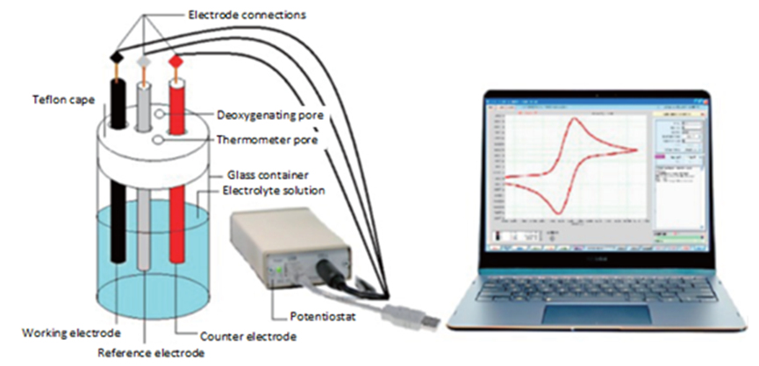

**Fig 1:** set up of cyclic voltammetry

**3. RESULTS AND DISCUSSION**

**3.1Spectroscopic characterization of Fe3O4 NPs**

**3.1**.**1** **XRD patterns of Fe3O4 NPs oxide nanoparticles via pulse laser ablation technique**

By examining the diffraction of X-rays at particular angles, X-ray diffraction (XRD) analysis can be used to identify metallic oxide crystals. The XRD spectrum of iron oxide nanoparticles (NPs) made from garlic peel extract using the environmentally friendly pulsed laser ablation method at 300 Mj is displayed in Figure 1 (A-C). The findings demonstrated the existence of a dominating magnetite phase of iron oxide nanoparticles at the plane of (220) with a cubic face center structure, which is equivalent to the 96-210-8029 reference code on the JCPDS card. Furthermore, as seen in figure 1 A [1], no discernible diffraction peaks that belonged to the extract of garlic peels were found.

The Debye-Scherrer formula (D = 0.89 * λ/β * Cosθ) was used to determine the crystal sizes (C.S.) of iron oxide nanoparticles. where (θ) is the diffraction angle, (λ) is the wavelength of the X-ray spectrum, and (β) is the half breadth at half maximum of the XRD peaks. The prepared samples' XRD results, including the pos. (angle), d-spacing, height, Rel. intensity, FWHM, Area, crystallite size of each element, and micron strain, are summarized in Tables 1.

**Figure 2.** B. XRD patterns of Fe3O4 NPs (magnétite) from garlic peelsextract via PLA technique at 300 Mj.

**Table 2.** summarizes the XRD results for the prepared samples of iron oxide NPs at 300 Mj, including the pos. (angle), d-spacing, height, Rel. intensity, FWHM, Area, crystallite size of each element, and Micron strain.

|  |  |  |  |  |  |  |  |  |  |  |
| --- | --- | --- | --- | --- | --- | --- | --- | --- | --- | --- |
| No. | Pos. [°2θ] | d-spacing [Å] | Height [cts] | Rel. Int. [%] | FWHM Left [°2θ] | Area calc. | Area [cts*°2θ] | Crystallite Size only [Å] | Crystallite Size (nm) | Micro Strain only [%] |
| 1 | 23.8881 | 3.72204 | 494.34 | 27.7 | 0.1694 | 113.24 | 113.24 | 5880 | 58.80 | 0.3164 |
| 2 | 32.9107 | 2.71933 | 1784.33 | 100 | 0.1501 | 324.8 | 324.8 | 8040 | 80.40 | 0.16915 |
| 3 | 35.3917 | 2.53418 | 1270.59 | 71.21 | 0.1476 | 230.09 | 230.09 | 8250 | 82.50 | 0.15361 |
| 4 | 40.6242 | 2.21903 | 358.61 | 20.1 | 0.1587 | 58.69 | 58.69 | 6230 | 62.30 | 0.17823 |
| 5 | 49.236 | 1.84916 | 730.6 | 40.95 | 0.1381 | 135.02 | 135.02 | 9240 | 92.40 | 0.10006 |
| 6 | 53.8439 | 1.70128 | 1029.65 | 57.71 | 0.1222 | 165.63 | 165.63 | 1266 | 12.66 | 0.06721 |
| 7 | 57.3259 | 1.60594 | 131.17 | 7.35 | 0.2943 | 65.07 | 65.07 | 2410 | 24.10 | 0.33377 |
| 8 | 62.2294 | 1.49065 | 661.75 | 37.09 | 0.1205 | 116.56 | 116.56 | 1376 | 13.76 | 0.05418 |
| 9 | 63.7969 | 1.45775 | 694.8 | 38.94 | 0.1201 | 115.31 | 115.31 | 1504 | 15.04 | 0.04846 |
| 10 | 71.7401 | 1.31462 | 252.57 | 14.15 | 0.1101 | 45.67 | 45.67 | 1086 | 10.86 | 0.06052 |
| 11 | 75.2719 | 1.26146 | 127.28 | 7.13 | 0.1318 | 17.29 | 17.29 | 9520 | 95.20 | 0.06628 |

**3.1**.**2** **FESEM images of Fe3O4 NPs via pulse laser ablation technique**

Emission Filed Iron oxide nanoparticle shape, size, aggregation, and homogeneity are all studied using pictures from scanning electron microscopy (FE-SEM). The surface morphology of synthetic iron oxide was investigated using a FESEM. We investigated the surface morphological characteristics of iron oxide, which was created by mixing iron salt with garlic peel extract, using the pulse laser ablation method at 300 Mj. FE-SEM confirmed the iron oxide nanoparticles' narrow size distribution and nanorock shape, as seen in Figure 4 A-C. Iron oxide nanoparticles at 300 Mj have a particle size value between 53.04 and 67.52 nm, as figure 4C [2] illustrates. [17].

The iron oxide nanoparticles' intermediate size distribution and structure were confirmed by FE-SEM. The nanocubes in Figure 5A–C show the intermediate size distribution and structure of the iron oxide nanoparticles made from PLA. The range of iron oxide nanoparticle sizes, which range from 44.78 to 49.17 nm, is shown in Figure 5C. The size of the iron oxide nanoparticles decreases as the energy increases. This is the outcome of the crystals being subjected to the heat energy of the laser, which causes them to fragment into smaller fragments. This outcome aligns with a reference provided by Muslim A. Abid [3].[18].

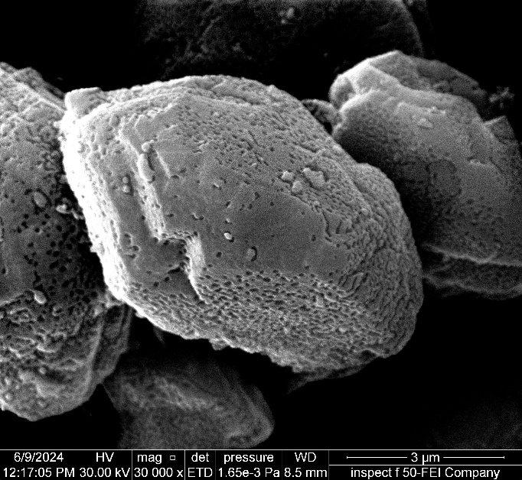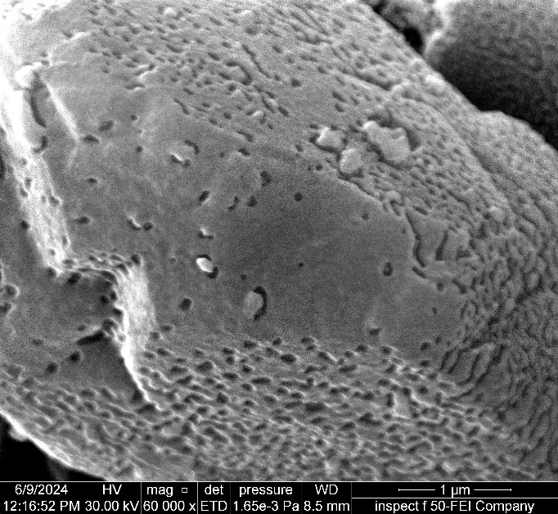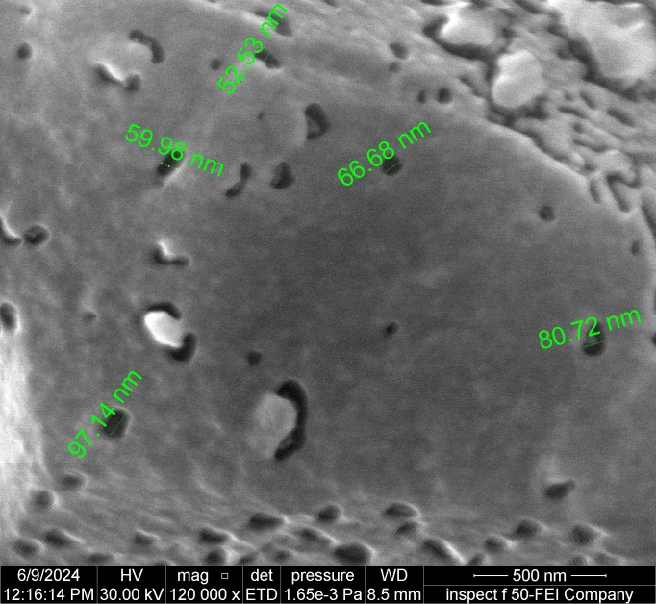

A

A

A

**Figure 5:** FE-SEM imagesof Fe3O4 NPs (magnétite) from garlic peelsextract via PLA technique at 300 Mj, A) magnification power 3 µm, B) magnification power 1 µm, and C) magnification power 500 nm.

**3.1**.3**Mapping-EDS images of Fe3O4 NPs via pulse laser ablation technique**

Energy dispersive X-ray spectroscopy (EDX) is an analytical technique used in element analysis. Figure 8 (A-C) shows the EDX of synthetic iron oxide NPs derived from garlic peel extract at 300 Mj. The peaks at 5.2, 6.3, and 6.9 keV correspond to Fe binding energies, while the oxygen peak is at 0.5 keV. The EDX analysis indicated the presence of both iron and oxygen in NPs. The EDX quantification produced atomic percentages of 48.0% O and 52.0% Fe, as reported in Table 5. The microscope was outfitted with an EDX system, which captured a SEM image of the sample at Maps resolution of 768 x 512.

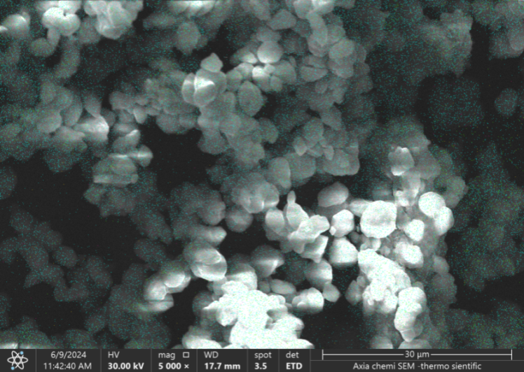

A

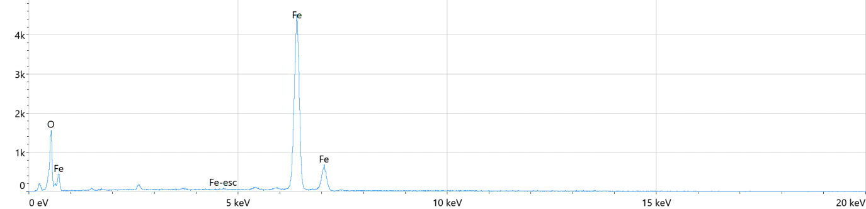

B

|  |  |
| --- | --- |
| C |  |

**Figure 8:** A) SEM imageof Fe3O4 NPs (magnétite) from garlic peelsextract via PLA technique at 200 Mj with magnification 30 µm, B) EDX image of Fe3O4 NPs (magnétite) from garlic peelsextract via PLA technique at 200 Mj, C) mapping images with magnification power 30 µm.

**Table 5.** summarizes the Energy dispersive x-ray results for the prepared samples of iron oxide NPs at 300 Mj, including the element, atomic, atomic error, weight, weight error.

|  |  |  |  |  |
| --- | --- | --- | --- | --- |
| **Element** | **Atomic %** | **Atomic % Error** | **Weight %** | **Weight % Error** |
| O | 48.0 | 0.6 | 20.9 | 0.3 |
| Fe | 52.0 | 0.3 | 79.1 | 0.5 |

The electrochemical behavior of Fe3O4 nanoparticles was studied by influencing their size, shape and surface properties under different concentrations, scanning rates, pH, etc.

**3.2.1 Calibration curve**

One of the most important studies in the electrochemistry of Fe3O4 nanoparticles in blood medium is the detection limit at low concentration. It was found from the results that the gradual rise of Fe3O4 nanoparticles causes the appearance of the oxidation current peak at 1 V. Figure 4 shows the cyclic voltammetry plot of Fe3O4 nanoparticles in blood medium at different concentrations with the growth of the oxidation peak at 1 V. It can be seen from Figure 5 that the anodic peak began to appear at 0.01 mM. Figure 5 is a good linear fit between the oxidation current peak and different concentrations of Fe3O4 nanoparticles in blood medium with the equation Y = 125.15x + 52.533 with high sensitivity R2 = 0.9976. From Figure 6, the low detection limit of Fe3O4 nanoparticles at 0.01 mM in blood medium can be determined, so electrochemical analysis is a good method to find the low concentration activity [20].

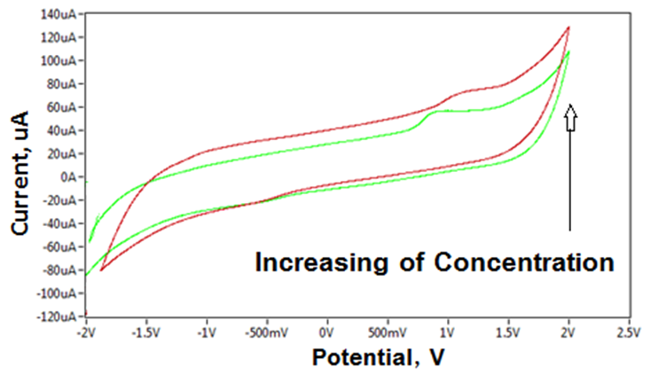

**Figure 5:** cyclic voltammogram of Fe3O4 NPs at different concentrations in serum blood medium, using GCE as working electrode and Ag/AgCl as reference electrode at scan rate 100 mVsec-1.

**Figure 6:** plotting diagram of redox current peak of Fe3O4 NPs in serum blood medium against to different concentrations.

**3.2.3 Effect Different Scan Rate Study**

Scan rates were varied to investigate the kinetics of electrochemical processes of Fe3O4 nanoparticles in serum blood medium. The scan rate used in cyclic voltammetry experiments can affect the observed redox behavior. Higher scan rates can reveal faster electron transfer kinetics but may also lead to increased polarization and less reversible redox processes. By understanding and controlling these key factors, research avenues can be found to improve the electrochemical properties of Fe3O4 nanoparticles to enhance their performance as contrast agents in MRI, taking advantage of the redox behavior and improving the electron transfer kinetics [21]. Figure 7 illustrated oxidation current peak of Fe3O4 NPs in blood medium enhanced gradually against to increasing the scan rates from 0.01 – 0.1 Vsec-1. The relationship was organized in Figure 8 by the equation:

Y = 848.57X – 11.143 with high sensitivity of R2 = 0.9727

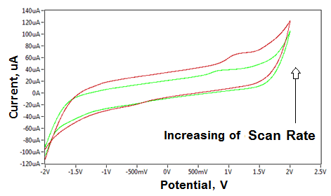

**Figure 7:** cyclic voltammogram of Fe3O4 NPs at different scan rates (0.01-0.1 Vsec-1) in serum blood medium, using GCE as working electrode and Ag/AgCl as reference electrode.

**Figure 8:** plotting diagram of redox oxidation peak current of Fe3O4 NPs in serum blood medium against to different scan rate (0.01 – 0.1 Vsec-1).

**3.2.4 Effect Different pH Study**

Ionic strength, pH, and specific ions present in the blood solution can affect the double layer structure, ion diffusion, and redox kinetics at the nanoparticle-blood interface. The study was included the **Fe3O4 NPs** in both acidic and alkaline blood medium:

In Fig.9 shows the oxidation peak current of **Fe3O4 NPs** in acidic pH of blood medium enhanced to higher current (at pH=5), while the oxidation peak was disappeared in alkaline blood medium (at pH= 9), so the pH was effected as antioxidant agent in alkaline blood medium of the nanoparticles, and oxidant effect in acidic blood medium as shown in Fig. 10 [22].

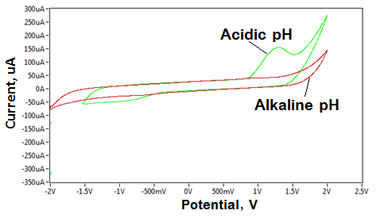

**Figure 9:** cyclic voltammogram of Fe3O4 NPs at different pH (green line in acidic medium and red line in alkaline medium) in serum blood medium, using GCE as working electrode and Ag/AgCl as reference electrode.

**Figure 10:** relationship between the oxidation current peak of Fe3O4 NPs in blood medium against to different pH (4 – 9).

**3.2.5 Effect ascorbic acid study**

Ascorbic acid acts as a reducing agent, helping to prevent the oxidation of iron nanoparticles by donating electrons. This can prevent the formation of iron oxides, which can degrade the quality and functionality of the nanoparticles. The presence of ascorbic acid can stabilize iron nanoparticles in the blood medium, preventing agglomeration and maintaining their dispersion. Ascorbic acid can affect the pH of the solution. A low pH may promote iron oxidation, while a neutral or slightly acidic environment can help stabilize iron nanoparticles. Ascorbic acid can form complexes with iron, which can change the oxidation state and affect the redox chemistry of iron nanoparticles. Overall, ascorbic acid plays a protective and stabilizing role in the oxidation of iron nanoparticles, making it a valuable additive in applications where maintaining the integrity of iron nanoparticles is critical.

Fig. 11 and 12 show the effect of AA solution on the oxidation properties of Fe3O4 NPs in blood medium, it was found the oxidation peak of Iron NPs disappeared after added AA, so AA acts a good antioxidant reagent of Fe3O4 NPs in blood medium [23].

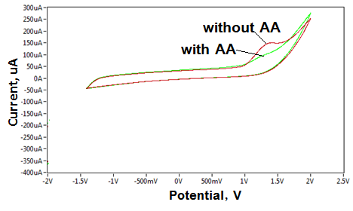

**Fig. 11:** cyclic voltammogram of Fe3O4 NPs in blood medium with and without ascorbic acid on GCE at 0.1 Vsec-1.

**Fig. 12:** relationship between oxidation current peak of Fe3O4 NPs in blood medium against to different concentration of ascorbic acid.

**3.2.6 Reliability and Stability Study**

A reliability and stability study focuses on assessing the consistency and reliability of a system or process over time. By conducting a comprehensive reliability and stability study. The reliability and stability in blood medium of Iron NPs were tested at ten-fold oxidation as shown in Fig. 13. The relative standard deviation (RSD) was ±1.53% of the peak oxidation current of Fe3O4 [24]. Therefore, the nanoparticles act as a homogeneous electrochemical catalyst in the analysis results of the reaction of Iron NPs with blood components by cyclic voltages [25].

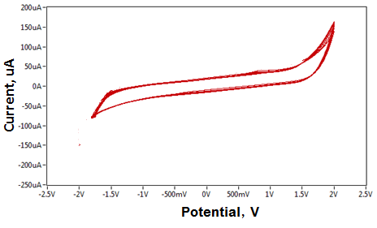

**Fig 13:** cyclic voltammogram of Fe3O4 NPs in blood medium at ten times scanning

**CONCLUSION**

Further studies may explore the influence of several parameters, such as nanoparticle size and shape, on the electrochemical behavior and contrast enhancement in MRI. The electrochemical behavior of Fe3O4 NPs was influenced by their size, shape, and surface properties. Smaller nanoparticles generally exhibited faster electron transfer kinetics, as evidenced by lower peak separation values ​​in cyclic voltammetry plots. The electrochemical data complemented other characterization techniques, such as different concentrations, scan rates, and a comprehensive understanding of the pH of the nanoparticle properties and their potential as contrast medium.The small size of the Fe3O4 NPs showed their effect in the blood medium with low oxidation effect in alkaline pH, especially after adding ascorbic acid.

**REFERENCES**

1. Luma Naji Joudha, Dunya Ali Mustafa, Hind Moafak AbdulJabbar and Muhammed Mizher Radhi, Assessment Study of the Effect of Using Ascorbic Acid with and WithoutContrast Agent on the Blood Samples Exposed with Different Doses of X-Ray inFluoroscopy by Cyclic Voltammetry, Sarc. Jr. med. Sci. vol-3, issue-6 (2024) pp-17-32, DOI-https://doi.org/10.5281/zenodo.11641366
2. Sara Majeed Hameed, Muhammed Mizher Radhi, Ahmed A. Mohsin, Comparison Study between the Contrast Media of Iodine and Iodine Nanoparticles in Physicochemical Properties in CT-scan Imaging, J Nanostruct 11(3): 543-553, 2021
3. HibaKarim Abd, Muhammed Mizher Radhi, The Use of Manganese Nano-Molecular Solution as Alternative Contrast Media in CT-Scan Imaging,Annals of R.S.C.B., ISSN:1583-6258, Vol. 25, Issue 6, 2021, Pages. 7650 – 7663.
4. Radhi, M. M., Al-Shimmari, H. A. T., Al-Mulla, E. A. J., Abdullah, A. A., &Wadday, A. G. (2017). New voltammetric study of MgCl2 as alternative contrast media in MRI molecular imaging. Nano Biomed. Eng, 9(2), 152-161.
5. Dunya Ali Mustafa, Haydar Abdulkadeer Taheer Al-Shimmari, Muhammed Mizher Radhi, Use of MgCl2 Nanoparticles as Alternative Contrast Media in Magnatic Resonance Imaging Molecular Imaging and Analyzed by Voltammetric Technique, Nano Biomed. Eng., 2020, 12(2): 148- 152.
6. Minh Dang Nguyen , Hung-Vu Tran , Shoujun Xu and T. Randall Lee, Fe3O4 Nanoparticles: Structures, Synthesis, Magnetic Properties, Surface Functionalization, and Emerging Applications, Appl. Sci. 2021, 11, 11301. <https://doi.org/10.3390/app112311301>
7. Bektenov Nessipkhan, Haider Falih Shamikh Al-Saedi , Mustafa Jassim Al-saray, Hamza Hameed Jasim, Ruaa Sattar, Batool Ali Ahmed, Ammar Kadhim Wabdan, Mohamad Adnan Alyas 8, ShakhnozaMavlyanova, A.M. Khurramov, Zokirov Muzaffar, Application of Iron Oxide Nanoparticles as MRI Contrast Enhancers: A study in Rabbits, J Nanostruct 13(3): 769-776, 2023
8. Jessica Wahsner, Eric M. Gale, Aurora Rodríguez-Rodríguez, and Peter Caravan, Chemistry of MRI Contrast Agents: Current Challenges and New Frontiers, Chem Rev. 2019 Jan 23; 119(2): 957–1057.doi: 10.1021/acs.chemrev.8b00363
9. Victoriya ZheltovaAnnaVlasovaNataliaBobryshevaShow all 8 authorsOlgaOsmolovskaya, Fe3O4@HAp core–shell nanoparticles as MRI contrast agent: Synthesis, characterization and theoretical and experimental study of shell impact on magnetic properties, 2020Applied Surface Science 531(18):147352, DOI: 10.1016/j.apsusc.2020.147352
10. Gini Rani a, Kadirvelu Krishna b, K.N. Yogalakshmi, Enhancing the electrochemical performance of Fe3O4 nanoparticles layered carbon electrodes in microbial electrolysis cell, Journal of Environmental Chemical Engineering, Volume 9, Issue 6, December 2021, 106326
11. Alessandra Accoglia, Luca Bertolia, Gabriele Panzeria, Eugenio Gibertinia, Ruggiero Pescea, Gianlorenzo Bussettib, Luca Magagnina, Electrochemical characterization of magnetite (Fe3O4) nano-aggregates in acidic and alkaline solutions, ACS Omega 2021, 6, 41, 26880–26887 <https://doi.org/10.1021/acsomega.1c03142>
12. Alessandra Accoglia, Luca Bertolia, Gabriele Panzeria, Eugenio Gibertinia, Ruggiero Pescea, Gianlorenzo Bussettib, Luca Magagnina, Electrochemical characterization of magnetite (Fe3O4) nano-aggregates in acidic and alkaline solutions, ACS Omega 2021, 6, 41,26880–26887.

<https://doi.org/10.1021/acsomega.1c03142>

1. Irene Fernández-Barahona, María Muñoz-Hernando, Jesus Ruiz-Cabello, Fernando Herranz, and Juan Pellico Iron Oxide Nanoparticles: An Alternative for Positive Contrast in Magnetic Resonance Imaging, Inorganics 2020, 8, 28; doi:10.3390/inorganics8040028.
2. Annika Kasten,CordulaGrüttner,Jens-Peter Kühn,RainerBader,JulianePasold,Bernhard Frerich, Comparative In Vitro Study on Magnetic Iron Oxide Nanoparticles for MRI Tracking of Adipose Tissue-Derived Progenitor Cells, PLoS ONE 9(9): e108055. doi:10.1371/journal.pone.0108055
3. Muhammed Mizher Radhi, Emad A. Jaffar Al-Mulla, Use of a grafted polymer electrode to study mercury ions by cyclic voltammetry, Research on Chemical Intermediates, 2015, Volume 41, Issue 3, pp 1413-1420
4. Sikdar, D., Roy, K., & Debnath, S. C. (2022). Green and sustainable biosynthesis of iron oxide nanoparticle (ION) from pomegranate seed and the development of highly reinforced ION based natural rubber (NR) nanocomposite in presence of epoxidized natural rubber (ENR) as compatibilizer. Current Research in Green and Sustainable Chemistry, 5, 100256.‏
5. Abid, M. A., Abid, D. A., Aziz, W. J., & Rashid, T. M. (2021). Iron oxide nanoparticles synthesized using garlic and onion peel extracts rapidly degrade methylene blue dye. Physica B: Condensed Matter, 622, 413277.‏
6. Abid, M. A., & Kadhim, D. A. (2020). Novel comparison of iron oxide nanoparticle preparation by mixing iron chloride with henna leaf extract with and without applied pulsed laser ablation for methylene blue degradation. Journal of Environmental Chemical Engineering, 8(5), 104138.‏
7. Crețu, B. E. B., Dodi, G., Shavandi, A., Gardikiotis, I., Șerban, I. L., & Balan, V. (2021). Imaging constructs: the rise of iron oxide nanoparticles. Molecules, 26(11), 3437.‏
8. R.M. Shaheen, N.N.A. Bt Nik Ab Razak, M.M. Radhi , N. Binti Suardi, M. Mohammed, Comparative bio -effect of gadolinium with alternative contrast medium of magnesium chloride and zinc oxide nanoparticles on single -strand DNA following exposure to magnetic resonance imaging, International Journal of Radiation Research, January 2024, Volume 22, No 1, 131-137.
9. D. AlQahtani, Ahmed Hameed, Enas Aljuhani, Reem Shah, Arwa Alharbi, Basim H. Asghar, Nashwa M. El-Metwaly,  Iron oxide nanopowder based electrochemical sensor for sensitive voltammetric quantification of midodrine, Arabian Journal of Chemistry Volume 14, Issue 12, 2021, 103446.
10. SO Kareem, TM Adeleye, and RO Ojo, Effects of pH, temperature and agitation on the biosynthesis of iron nanoparticles produced by Trichoderma species,2020 IOP Conf. Ser.: Mater. Sci. Eng. 805 012036DOI 10.1088/1757-899X/805/1/012036
11. Maysara Samer Khalaf, Muhammed Mizher Radhi, Zainab Oun Ali, Impact viscosity of blood on the diffusion coefficient in the presence of ascorbic acid using cyclic voltammetry, Research in Analytical and Bioanalytical Chemistry 2018, Volume 1, Issue 1, Page No: 1-7
12. C. Engin, S. Yilmaz, G. Saglikoglu, S. Yagmur, and M. Sadikoglu, "Electroanalytical investigation of paracetamol on glassy carbon electrode by voltammetry," Int J Electrochem Sci, vol. 10, pp. 1916-1925, 2015.
13. Eric S. Rountree, Brian D. McCarthy, Thomas T. Eisenhart, and Jillian L. Dempsey, Evaluation of Homogeneous Electrocatalysts by Cyclic Voltammetry, inorg. Chem. 2014, 53, 19, 9983–10002